**Data table :**

Js link:

header

<!-- Datatable css -->

<link href="{{ asset('public/backend/lib/highlightjs/github.css') }}" rel="stylesheet">

<link href="{{ asset('public/backend/lib/datatables/jquery.dataTables.css') }}" rel="stylesheet">

<link href="{{ asset('public/backend/lib/select2/css/select2.min.css') }}" rel="stylesheet">

Top of body tag:

<script src="{{ asset('public/backend/lib/highlightjs/highlight.pack.js') }}"></script>

<script src="{{ asset('public/backend/lib/datatables/jquery.dataTables.js') }}"></script>

<script src="{{ asset('public/backend/lib/datatables-responsive/dataTables.responsive.js') }}"></script>

<script src="{{ asset('public/backend/lib/select2/js/select2.min.js') }}"></script>

<script>

$(function(){

'use strict';

$('#datatable1').DataTable({

responsive: true,

language: {

searchPlaceholder: 'Search...',

sSearch: '',

lengthMenu: '_MENU_ items/page',

}

});

$('#datatable2').DataTable({

bLengthChange: false,

searching: false,

responsive: true

});

// Select2

$('.dataTables_length select').select2({ minimumResultsForSearch: Infinity });

});

</script>

---------------------------------------------------------------------------------------------------------------------------------------

**Sweet alert for delete:**

<a href=”” id=”delete”></a>

<script src="{{ asset('https://unpkg.com/sweetalert/dist/sweetalert.min.js')}}"></script>

<script>

$(document).on("click", "#delete", function(e){

e.preventDefault();

var link = $(this).attr("href");

swal({

title: "Are you Want to delete?",

text: "Once Delete, This will be Permanently Delete!",

icon: "warning",

buttons: true,

dangerMode: true,

})

.then((willDelete) => {

if (willDelete) {

window.location.href = link;

} else {

swal("Safe Data!");

}

});

});

</script>

--------------------------------------------------------------------------------------------------------------------

**Multiple input**

**Search -** Bootstrap multi tags input cdn

Css link:

<link href="https://cdn.jsdelivr.net/bootstrap.tagsinput/0.8.0/bootstrap-tagsinput.css" rel="stylesheet"/>

Js link:

<script src="https://cdnjs.cloudflare.com/ajax/libs/jquery/2.2.2/jquery.min.js"></script>

<script src="https://cdn.jsdelivr.net/bootstrap.tagsinput/0.8.0/bootstrap-tagsinput.min.js"></script>

In from input :

<div class="col-lg-4">

<div class="form-group">

<label class="form-control-label">Product Size: <span class="tx-danger">*</span>

</label>

<input class="form-control" type="text" name="product_size" id="size" data-role="tagsinput" >

</div></div>

Red marks are added for multiple tags input

**Summer editor**

<div class="col-lg-12">

<div class="form-group">

<label class="form-control-label">Product Details: <span class="tx-danger">*</span></label>

<textarea class="form-control" id="summernote" name="product_details">

</textarea>

</div>

</div>

**Css**:

<link rel="stylesheet" href="{{ asset('public/backend/css/starlight.css') }}">

<link href="{{ asset('public/backend/lib/summernote/summernote-bs4.css') }}" rel="stylesheet">

Js:

<script src="{{ asset('public/backend/lib/medium-editor/medium-editor.js') }}"></script>

<script src="{{ asset('public/backend/lib/summernote/summernote-bs4.min.js') }}"></script>

<script src="{{ asset('public/backend/js/starlight.js') }}"></script>

<script>

$(function(){

'use strict';

// Inline editor

var editor = new MediumEditor('.editable');

// Summernote editor

$('#summernote').summernote({

height: 150,

tooltip: false

})

});

</script>

---------------------------------------------------------------------------------------

**Toaster cdn js and css:**

 <link rel="stylesheet" type="text/css" href="https://cdnjs.cloudflare.com/ajax/libs/toastr.js/latest/css/toastr.css">

 <script type="text/javascript" src="https://cdnjs.cloudflare.com/ajax/libs/toastr.js/latest/js/toastr.min.js"></script>

<script>

        @if(Session::has('messege'))

          var type="{{Session::get('alert-type','info')}}"

          switch(type){

              case 'info':

                   toastr.info("{{ Session::get('messege') }}");

                   break;

              case 'success':

                  toastr.success("{{ Session::get('messege') }}");

                  break;

              case 'warning':

                 toastr.warning("{{ Session::get('messege') }}");

                  break;

              case 'error':

                  toastr.error("{{ Session::get('messege') }}");

                  break;

          }

        @endif

     </script>

**In a function :**

 $notification=array(

            'messege'=>'Brand Updated Successfully',

            'alert-type'=>'success'

             );

           return Redirect()->route('brands')->with($notification);

**--------------------------------------------------**

**Product features:**

**Category with sub category ajax:**

Note* Select all subcategories ,when select a category

Route::get('admin/product/add', 'Admin\ProductController@create')->name('add.product');

Js script add in bottom:

 <script type="text/javascript">

      $(document).ready(function(){

     $('select[name="category_id"]').on('change',function(){

          var category_id = $(this).val();

          if (category_id) {

            $.ajax({

              url: "{{ url('/get/subcategory/') }}/"+category_id,

              type:"GET",

              dataType:"json",

              success:function(data) {

              var d =$('select[name="subcategory_id"]').empty();

              $.each(data, function(key, value){

              $('select[name="subcategory_id"]').append('<option value="'+ value.id + '">' + value.subcategory_name + '</option>');

              });

              },

            });

          }else{

            alert('danger');

          }

            });

      });

 </script>

**Product->create.blade.php:**

<div class="col-lg-4">

                <div class="form-group mg-b-10-force">

                  <label class="form-control-label">Category: <span class="tx-danger">*</span></label>

       <select class="form-control select2" data-placeholder="Choose country" name="category_id">

                    <option label="Choose Category"></option>

                    @foreach($category as $row)

                    <option value="{{ $row->id }}">{{ $row->category_name }}</option>

                    @endforeach

                  </select>

                </div>

              </div><!-- col-4 -->

              <div class="col-lg-4">

                <div class="form-group mg-b-10-force">

                  <label class="form-control-label">Sub Category: <span class="tx-danger">*</span></label>

       <select class="form-control select2" data-placeholder="Choose country" name="subcategory_id">

                  </select>

                </div>

              </div><!-- col-4 -->

**Product controller:**

    public function create(){

        $category = DB::table('categories')->get();

        $brand = DB::table('brands')->get();

       return view('admin.product.create',compact('category','brand'));

   }

   public function GetSubcat($category_id){

    $cat = DB::table('subcategories')->where('category_id',$category_id)->get();

    return json_encode($cat);

}

**Image show with ajax when insert multiple image with input :**

 <div class="col-lg-4">

                <div class="form-group">

                  <label class="form-control-label">Image One ( Main Thumbnali): <span class="tx-danger">*</span></label>

                 <label class="custom-file">

          <input type="file" id="file" class="custom-file-input" name="image_one" onchange="readURL(this);" required="">

          <span class="custom-file-control"></span>

          <img src="#" id="one">

            </label>

                </div>

              </div><!-- col-4 -->

               <div class="col-lg-4">

                <div class="form-group">

                  <label class="form-control-label">Image Two: <span class="tx-danger">*</span></label>

                 <label class="custom-file">

          <input type="file" id="file" class="custom-file-input" name="image_two" onchange="readURL2(this);" required="">

          <span class="custom-file-control"></span>

          <img src="#" id="two">

            </label>

                </div>

              </div><!-- col-4 -->

         <div class="col-lg-4">

                <div class="form-group">

                    <label class="form-control-label">Image Three: <span class="tx-danger">*</span></label>

                    <label class="custom-file">

                    <input type="file" id="file" class="custom-file-input" name="image_three" onchange="readURL3(this);" required="">

                    <span class="custom-file-control"></span>

                    <img src="#" id="three">

                    </label>

                </div>

              </div><!-- col-4 -->

 <script type="text/javascript">

  function readURL(input){

    if (input.files && input.files[0]) {

      var reader = new FileReader();

      reader.onload = function(e) {

        $('#one')

        .attr('src', e.target.result)

        .width(80)

        .height(80);

      };

      reader.readAsDataURL(input.files[0]);

    }

  }

</script>

 <script type="text/javascript">

  function readURL2(input){

    if (input.files && input.files[0]) {

      var reader = new FileReader();

      reader.onload = function(e) {

        $('#two')

        .attr('src', e.target.result)

        .width(80)

        .height(80);

      };

      reader.readAsDataURL(input.files[0]);

    }

  }

</script>

 <script type="text/javascript">

  function readURL3(input){

    if (input.files && input.files[0]) {

      var reader = new FileReader();

      reader.onload = function(e) {

        $('#three')

        .attr('src', e.target.result)

        .width(80)

        .height(80);

      };

      reader.readAsDataURL(input.files[0]);

    }

  }

</script>

**Search : Image/intervention.io**

**Command: composer require intervention/image**

After you have installed Intervention Image, open your Laravel config file config/app.php and add the following lines.

In the $providers array add the service providers for this package.

**Intervention\Image\ImageServiceProvider::class**

Add the facade of this package to the $aliases array.

**'Image' => Intervention\Image\Facades\Image::class**

**Command: php artisan vendor:publish --provider="Intervention\Image\ImageServiceProviderLaravelRecent"**

**Multi language:**

php artisan make:controller Admin/PostController

public function __construct()

    {

        $this->middleware('auth:admin');

    }

php artisan make:migration create_post_category_table --create=post_category

$table->bigIncrements('id');

$table->string('category_name_en');

$table->string('category_name_in');

$table->timestamps();

php artisan make:migration create_posts_table --create=posts

$table->bigIncrements('id');

$table->integer('category_id');

$table->string('post_title_en');

$table->string('post_title_in');

$table->string('post_image');

$table->text('details_en');

$table->text('details_in');

$table->timestamps();

-----------------------------------

**Email verification for default one :**

1)Set up eve.php with mail trap user is and pass and tls and port no.

2)go laravel doc->email verification and add this in user model

Use Illuminate\Contracts\Auth\MustVerifyEmail;

class User extends Authenticatable implements MustVerifyEmail

3)web.php

Auth::routes(['verify' => true]);

-------------------------------------------------------------------------

**Shopping cart package install**

**Search= bumbummen99 laravel package**

**url-**

[**https://packagist.org/packages/bumbummen99/shoppingcart**](https://packagist.org/packages/bumbummen99/shoppingcart)

**command1:**

composer require bumbummen99/shoppingcart

**command2:**

php artisan vendor:publish --provider="Gloudemans\Shoppingcart\ShoppingcartServiceProvider" --tag="migrations"

**Wishlist using ajax**

php artisan make:migration create_wishlists_table --create=wishlists

php artisan make:controller WishlistsController

sweet alert2 link:

<script src="https://cdn.jsdelivr.net/npm/sweetalert2@10"></script>

<link rel="stylesheet" href="sweetalert2.min.css">

{{-- Jquery cdn minified: --}}

<script src="https://code.jquery.com/jquery-3.5.1.min.js" integrity="sha256-9/aliU8dGd2tb6OSsuzixeV4y/faTqgFtohetphbbj0=" crossorigin="anonymous"></script>

<button class="addwishlist" data-id="{{ $row->id }}" >

            <div class="product_fav"><i class="fas fa-heart"></i></div>

            </button>

<script type="text/javascript">

    $(document).ready(function(){

      $('.addwishlist').on('click', function(){

         var id = $(this).data('id');

         if (id) {

             $.ajax({

                 url: " {{ url('add/wishlist/') }}/"+id,

                 type:"GET",

                 datType:"json",

                 success:function(data){

              const Toast = Swal.mixin({

                   toast: true,

                   position: 'top-end',

                   showConfirmButton: false,

                   timer: 3000,

                   timerProgressBar: true,

                   onOpen: (toast) => {

                     toast.addEventListener('mouseenter', Swal.stopTimer)

                     toast.addEventListener('mouseleave', Swal.resumeTimer)

                   }

                 })

              if ($.isEmptyObject(data.error)) {

                 Toast.fire({

                   icon: 'success',

                   title: data.success

                 })

              }else{

                  Toast.fire({

                   icon: 'error',

                   title: data.error

                 })

              }

                 },

             });

         }else{

             alert('danger');

         }

      });

    });

 </script>

WishlistController:

<?php

namespace App\Http\Controllers;

use Illuminate\Http\Request;

use DB;

use Auth;

class WishlistController extends Controller

{

   public function addWishlist($id){

    $userid = Auth::id();

    $check = DB::table('wishlists')->where('user_id',$userid)->where('product_id',$id)->first();

    $data = array(

    'user_id' => $userid,

    'product_id' => $id,

    );

              if (Auth::Check()) {

             if ($check) {

              return \Response::json(['error' => 'Product Already Has on your wishlist']);

             }else{

                DB::table('wishlists')->insert($data);

          return \Response::json(['success' => 'Product Added on wishlist']);

             }

              }else{

          return \Response::json(['error' => 'At first loing your account']);

              }

   }

}

**Wishlist show in wishlist.blade.php**

CartController wishlist function

 public function wishlist(){

        $userid = Auth::id();

        $product = DB::table('wishlists')

                ->join('products','wishlists.product_id','products.id')

                ->select('products.*','wishlists.user_id')

                ->where('wishlists.user_id',$userid)

                ->get();

               // return response()->json($product);

                return view('pages.wishlist',compact('product'));

        }

Web.php

Route::get('user/wishlist/', 'CartController@wishlist')->name('user.wishlist');

Wishlist.blade.php

@extends('layouts.app')

@section('content')

@include('layouts.menubar')

<link rel="stylesheet" type="text/css" href="{{ asset('public/frontend/styles/cart_styles.css') }}">

<link rel="stylesheet" type="text/css" href="{{ asset('public/frontend/styles/cart_responsive.css') }}">

    <!-- Cart -->

    <div class="cart_section">

        <div class="container">

            <div class="row">

                <div class="col-lg-12">

                    <div class="cart_container">

                        <div class="cart_title">Your Wishlist Product</div>

                        <div class="cart_items">

                            <ul class="cart_list">

                              @foreach($product as $row)

        <li class="cart_item clearfix">

            <div class="cart_item_image text-center"><br><img src="{{ asset($row->image_one) }} " style="width: 70px; width: 70px;" alt=""></div>

            <div class="cart_item_info d-flex flex-md-row flex-column justify-content-between">

                <div class="cart_item_name cart_info_col">

                    <div class="cart_item_title">Name</div>

                    <div class="cart_item_text">{{ $row->product_name  }}</div>

                </div>

                @if($row->product_color == NULL)

                @else

                <div class="cart_item_color cart_info_col">

                    <div class="cart_item_title">Color</div>

                    <div class="cart_item_text"> {{ $row->product_color }}</div>

                </div>

                 @endif

                @if($row->product_size == NULL)

                @else

                <div class="cart_item_color cart_info_col">

                    <div class="cart_item_title">Size</div>

                    <div class="cart_item_text"> {{ $row->product_size }}</div>

                </div>

                @endif

                <div class="cart_item_color cart_info_col">

                    <div class="cart_item_title">Action</div><br>

                    <a href="#" class="btn btn-sm btn-danger">Add to Cart</a>

                </div>

            </div>

        </li>

                                @endforeach

                            </ul>

                        </div>

                    </div>

                </div>

            </div>

        </div>

    </div>

<script src="{{ asset('public/frontend/js/cart_custom.js') }}"></script>

@endsection

Page link:

                                                        <li><a href="{{ route('user.wishlist') }}">Wishlist</a></li>

Wishlist count

  @php

     $wishlist = DB::table('wishlists')->where('user_id',Auth::id())->get();

           @endphp

                                <div class="wishlist_count">{{ count($wishlist) }}</div>

**Shopping cart**

* Shopping cart package install

**Search= bumbummen99 laravel package**

**url-**

<https://packagist.org/packages/bumbummen99/shoppingcart>

**this url is for bombommen90 shoping cart document**

**command1:**

composer require bumbummen99/shoppingcart

**command2:**

php artisan vendor:publish --provider="Gloudemans\Shoppingcart\ShoppingcartServiceProvider" --tag="config"

This will give you a cart.php config file in which you can make changes to the packages behaivor.

**Ajax with add to cart:**

*Same js and css and jquery link up like **wishlists topic**, then add this script in button page

Ajax script :

 <script type="text/javascript">

   $(document).ready(function(){

     $('.addcart').on('click', function(){

        var id = $(this).data('id');

        if (id) {

            $.ajax({

                url: " {{ url('/add/to/cart/') }}/"+id,

                type:"GET",

                datType:"json",

                success:function(data){

             const Toast = Swal.mixin({

                  toast: true,

                  position: 'top-end',

                  showConfirmButton: false,

                  timer: 3000,

                  timerProgressBar: true,

                  onOpen: (toast) => {

                    toast.addEventListener('mouseenter', Swal.stopTimer)

                    toast.addEventListener('mouseleave', Swal.resumeTimer)

                  }

                })

             if ($.isEmptyObject(data.error)) {

                Toast.fire({

                  icon: 'success',

                  title: data.success

                })

             }else{

                 Toast.fire({

                  icon: 'error',

                  title: data.error

                })

             }

                },

            });

        }else{

            alert('danger');

        }

     });

   });

</script>

**Web .php**

Route::get('add/to/cart/{id}', 'CartController@AddCart');

Button:

<div class="product_extras">

     <button class="product_cart_button addcart" data-id="{{ $row->id }}">Add to Cart</button>

                </div>

**cartcontroller code:**

<?php

namespace App\Http\Controllers;

use Illuminate\Http\Request;

use DB;

use Cart;

use Response;

use Auth;

use Session;

class CartController extends Controller

{

    public function AddCart($id){

        $product = DB::table('products')->where('id',$id)->first();

         $data = array();

        if ($product->discount_price == NULL) {

            $data['id'] = $product->id;

            $data['name'] = $product->product_name;

            $data['qty'] = 1;

            $data['price'] = $product->selling_price;

            $data['weight'] = 1;

            $data['options']['image'] = $product->image_one;

            $data['options']['color'] = '';

            $data['options']['size'] = '';

             Cart::add($data);

             return \Response::json(['success' => 'Successfully Added on your Cart']);

        }else{

            $data['id'] = $product->id;

            $data['name'] = $product->product_name;

            $data['qty'] = 1;

            $data['price'] = $product->discount_price;

            $data['weight'] = 1;

            $data['options']['image'] = $product->image_one;

            $data['options']['color'] = '';

            $data['options']['size'] = '';

             Cart::add($data);

             return \Response::json(['success' => 'Successfully Added on your Cart']);

        }

           }

}

**For checking data insert or not:**

 public function check(){

            $content = Cart::content();

            return response()->json($content);

        }

**Web.php check route**

Route::get('check', 'CartController@check');

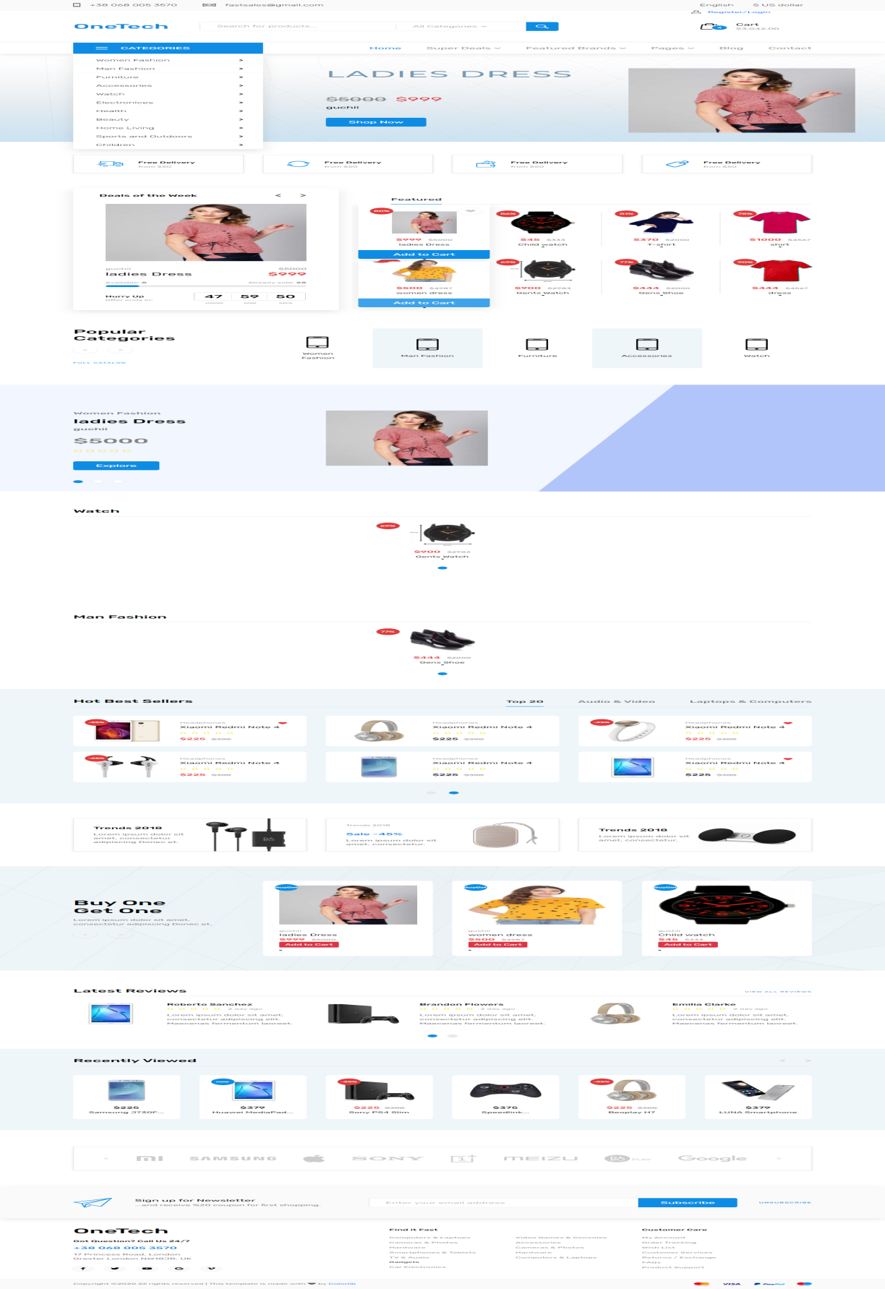

**----------------------------------------------------**

**Nav with javascript behavior :**

Without creating page can see content.

    <div class="viewed">

        <div class="container">

            <div class="row">

                <div class="col">

                    <div class="viewed_title_container">

                        <h3 class="viewed_title">Product Details</h3>

                        <div class="viewed_nav_container">

                            <div class="viewed_nav viewed_prev"><i class="fas fa-chevron-left"></i></div>

                            <div class="viewed_nav viewed_next"><i class="fas fa-chevron-right"></i></div>

                        </div>

                    </div>

<ul class="nav nav-tabs" id="myTab" role="tablist">

  <li class="nav-item">

    <a class="nav-link active" id="home-tab" data-toggle="tab" href="#home" role="tab" aria-controls="home" aria-selected="true">Product Details</a>

  </li>

  <li class="nav-item">

    <a class="nav-link" id="profile-tab" data-toggle="tab" href="#profile" role="tab" aria-controls="profile" aria-selected="false">Video Link</a>

  </li>

  <li class="nav-item">

    <a class="nav-link" id="contact-tab" data-toggle="tab" href="#contact" role="tab" aria-controls="contact" aria-selected="false">Product Review</a>

  </li>

</ul>

<div class="tab-content" id="myTabContent">

  <div class="tab-pane fade show active" id="home" role="tabpanel" aria-labelledby="home-tab">

    <br>{!! $product->product_details !!}</div>

  <div class="tab-pane fade" id="profile" role="tabpanel" aria-labelledby="profile-tab">

    <br>{{ $product->video_link }}</div>

  <div class="tab-pane fade" id="contact" role="tabpanel" aria-labelledby="contact-tab"><br>

  <div class="fb-comments" data-href="{{ Request::url() }}" data-width="" data-numposts="5"></div>

  </div>

</div>

                </div>

            </div>

        </div>

    </div>

**Product_details page add one product to cart:**

Product_details.blade.php

@extends('layouts.app')

@section('content')

@include('layouts.menubar')

<link rel="stylesheet" type="text/css" href="{{ asset('public/frontend/styles/product_styles.css') }}">

<link rel="stylesheet" type="text/css" href="{{ asset('public/frontend/styles/product_responsive.css') }}">

<!-- Single Product -->

    <div class="single_product">

        <div class="container">

            <div class="row">

                <!-- Images -->

                <div class="col-lg-2 order-lg-1 order-2">

                    <ul class="image_list">

                        <li data-image="{{ asset( $product->image_one ) }}"><img src="{{ asset( $product->image_one ) }}" alt=""></li>

                        <li data-image="{{ asset( $product->image_two ) }}"><img src="{{ asset( $product->image_two ) }}" alt=""></li>

                        <li data-image="{{ asset( $product->image_three ) }}"><img src="{{ asset( $product->image_three ) }}" alt=""></li>

                    </ul>

                </div>

                <!-- Selected Image -->

                <div class="col-lg-5 order-lg-2 order-1">

                    <div class="image_selected"><img src="{{ asset( $product->image_one ) }}" alt=""></div>

                </div>

                <!-- Description -->

                <div class="col-lg-5 order-3">

                    <div class="product_description">

                        <div class="product_category">{{ $product->category_name }} > {{ $product->subcategory_name }}</div>

                        <div class="product_name">{{ $product->product_name }}</div>

                        <div class="rating_r rating_r_4 product_rating"><i></i><i></i><i></i><i></i><i></i></div>

                        <div class="product_text"><p>

                      {!!  str_limit($product->product_details, $limit = 600 )  !!}

                        </p></div>

                        <div class="order_info d-flex flex-row">

         <form action="{{ url('cart/product/add/'.$product->id) }}" method="post">

            @csrf

          <div class="row">

            <div class="col-lg-4">

            <div class="form-group">

                <label for="exampleFormControlSelect1">Color</label>

                <select class="form-control input-lg" id="exampleFormControlSelect1" name="color">

                       @foreach($product_color as $color)

                    <option value="{{ $color }}">{{ $color }}</option>

                 @endforeach

                </select>

            </div>

            </div>

@if($product->product_size == NULL)

@else

<div class="col-lg-4">

            <div class="form-group">

                <label for="exampleFormControlSelect1">Size</label>

                <select class="form-control input-lg" id="exampleFormControlSelect1" name="size">

                     @foreach($product_size as $size)

                    <option value="{{ $size }}">{{ $size }}</option>

                     @endforeach

                </select>

            </div>

            </div>

            @endif

            <div class="col-lg-4">

            <div class="form-group">

                <label for="exampleFormControlSelect1">Quantity</label>

                 <input class="form-control" type="number" value="1" pattern="[0-9]" name="qty">

            </div>

            </div>

          </div>

                                </div>

 @if($product->discount_price == NULL)

<div class="product_price">${{ $product->selling_price }}<span> </div>

      @else

<div class="product_price">${{ $product->discount_price }}<span>${{ $product->selling_price }}</span></div>

      @endif

                                <div class="button_container">

                                    <button type="submit" class="button cart_button">Add to Cart</button>

                                    <div class="product_fav"><i class="fas fa-heart"></i></div>

                                </div>

<br><br>

                <!-- Go to www.addthis.com/dashboard to customize your tools -->

                <div class="addthis_inline_share_toolbox"></div>

                            </form>

                        </div>

                    </div>

                </div>

            </div>

        </div>

    </div>

    <!-- Recently Viewed -->

    <div class="viewed">

        <div class="container">

            <div class="row">

                <div class="col">

                    <div class="viewed_title_container">

                        <h3 class="viewed_title">Product Details</h3>

                        <div class="viewed_nav_container">

                            <div class="viewed_nav viewed_prev"><i class="fas fa-chevron-left"></i></div>

                            <div class="viewed_nav viewed_next"><i class="fas fa-chevron-right"></i></div>

                        </div>

                    </div>

<ul class="nav nav-tabs" id="myTab" role="tablist">

  <li class="nav-item">

    <a class="nav-link active" id="home-tab" data-toggle="tab" href="#home" role="tab" aria-controls="home" aria-selected="true">Product Details</a>

  </li>

  <li class="nav-item">

    <a class="nav-link" id="profile-tab" data-toggle="tab" href="#profile" role="tab" aria-controls="profile" aria-selected="false">Video Link</a>

  </li>

  <li class="nav-item">

    <a class="nav-link" id="contact-tab" data-toggle="tab" href="#contact" role="tab" aria-controls="contact" aria-selected="false">Product Review</a>

  </li>

</ul>

<div class="tab-content" id="myTabContent">

  <div class="tab-pane fade show active" id="home" role="tabpanel" aria-labelledby="home-tab">

    <br>{!! $product->product_details !!}</div>

  <div class="tab-pane fade" id="profile" role="tabpanel" aria-labelledby="profile-tab">

    <br>{{ $product->video_link }}</div>

  <div class="tab-pane fade" id="contact" role="tabpanel" aria-labelledby="contact-tab"><br>

  <div class="fb-comments" data-href="{{ Request::url() }}" data-width="" data-numposts="5"></div>

  </div>

</div>

                </div>

            </div>

        </div>

    </div>

<div id="fb-root"></div>

<script async defer crossorigin="anonymous" src="https://connect.facebook.net/en_US/sdk.js#xfbml=1&version=v6.0"></script>

<!-- Go to www.addthis.com/dashboard to customize your tools -->

<script type="text/javascript" src="//s7.addthis.com/js/300/addthis_widget.js#pubid=ra-5e4b85f98de5201f"></script>

@endsection

**ProductController**

<?php

namespace App\Http\Controllers;

use Illuminate\Http\Request;

use DB;

use Cart;

class ProductController extends Controller

{

    public function ProductView($id,$product_name){

        $product = DB::table('products')

                ->join('categories','products.category_id','categories.id')

                ->join('subcategories','products.subcategory_id','subcategories.id')

                ->join('brands','products.brand_id','brands.id')

                ->select('products.*','categories.category_name','subcategories.subcategory_name','brands.brand_name')

                ->where('products.id',$id)

                ->first();

        $color = $product->product_color;

        $product_color = explode(',', $color);

        $size = $product->product_size;

        $product_size = explode(',', $size);

        return view('pages.product_details',compact('product','product_color','product_size'));

    }

    public function AddCart(Request $request, $id){

        $product = DB::table('products')->where('id',$id)->first();

          $data = array();

         if ($product->discount_price == NULL) {

             $data['id'] = $product->id;

             $data['name'] = $product->product_name;

             $data['qty'] = $request->qty;

             $data['price'] = $product->selling_price;

             $data['weight'] = 1;

             $data['options']['image'] = $product->image_one;

             $data['options']['color'] = $request->color;

             $data['options']['size'] = $request->size;

              Cart::add($data);

             $notification=array(

                                'messege'=>'Product Successfully Added',

                                'alert-type'=>'success'

                                 );

                               return Redirect()->back()->with($notification);

         }else{

             $data['id'] = $product->id;

             $data['name'] = $product->product_name;

             $data['qty'] = $request->qty;

             $data['price'] = $product->discount_price;

             $data['weight'] = 1;

             $data['options']['image'] = $product->image_one;

             $data['options']['color'] = $request->color;

             $data['options']['size'] = $request->size;

              Cart::add($data);

              $notification=array(

                                'messege'=>'Product Successfully Added',

                                'alert-type'=>'success'

                                 );

                               return Redirect()->back()->with($notification);

            }

              }

}

**Web.php**

Route::get('/product/details/{id}/{product_name}', 'ProductController@ProductView');

Route::post('/cart/product/add/{id}', 'ProductController@AddCart');

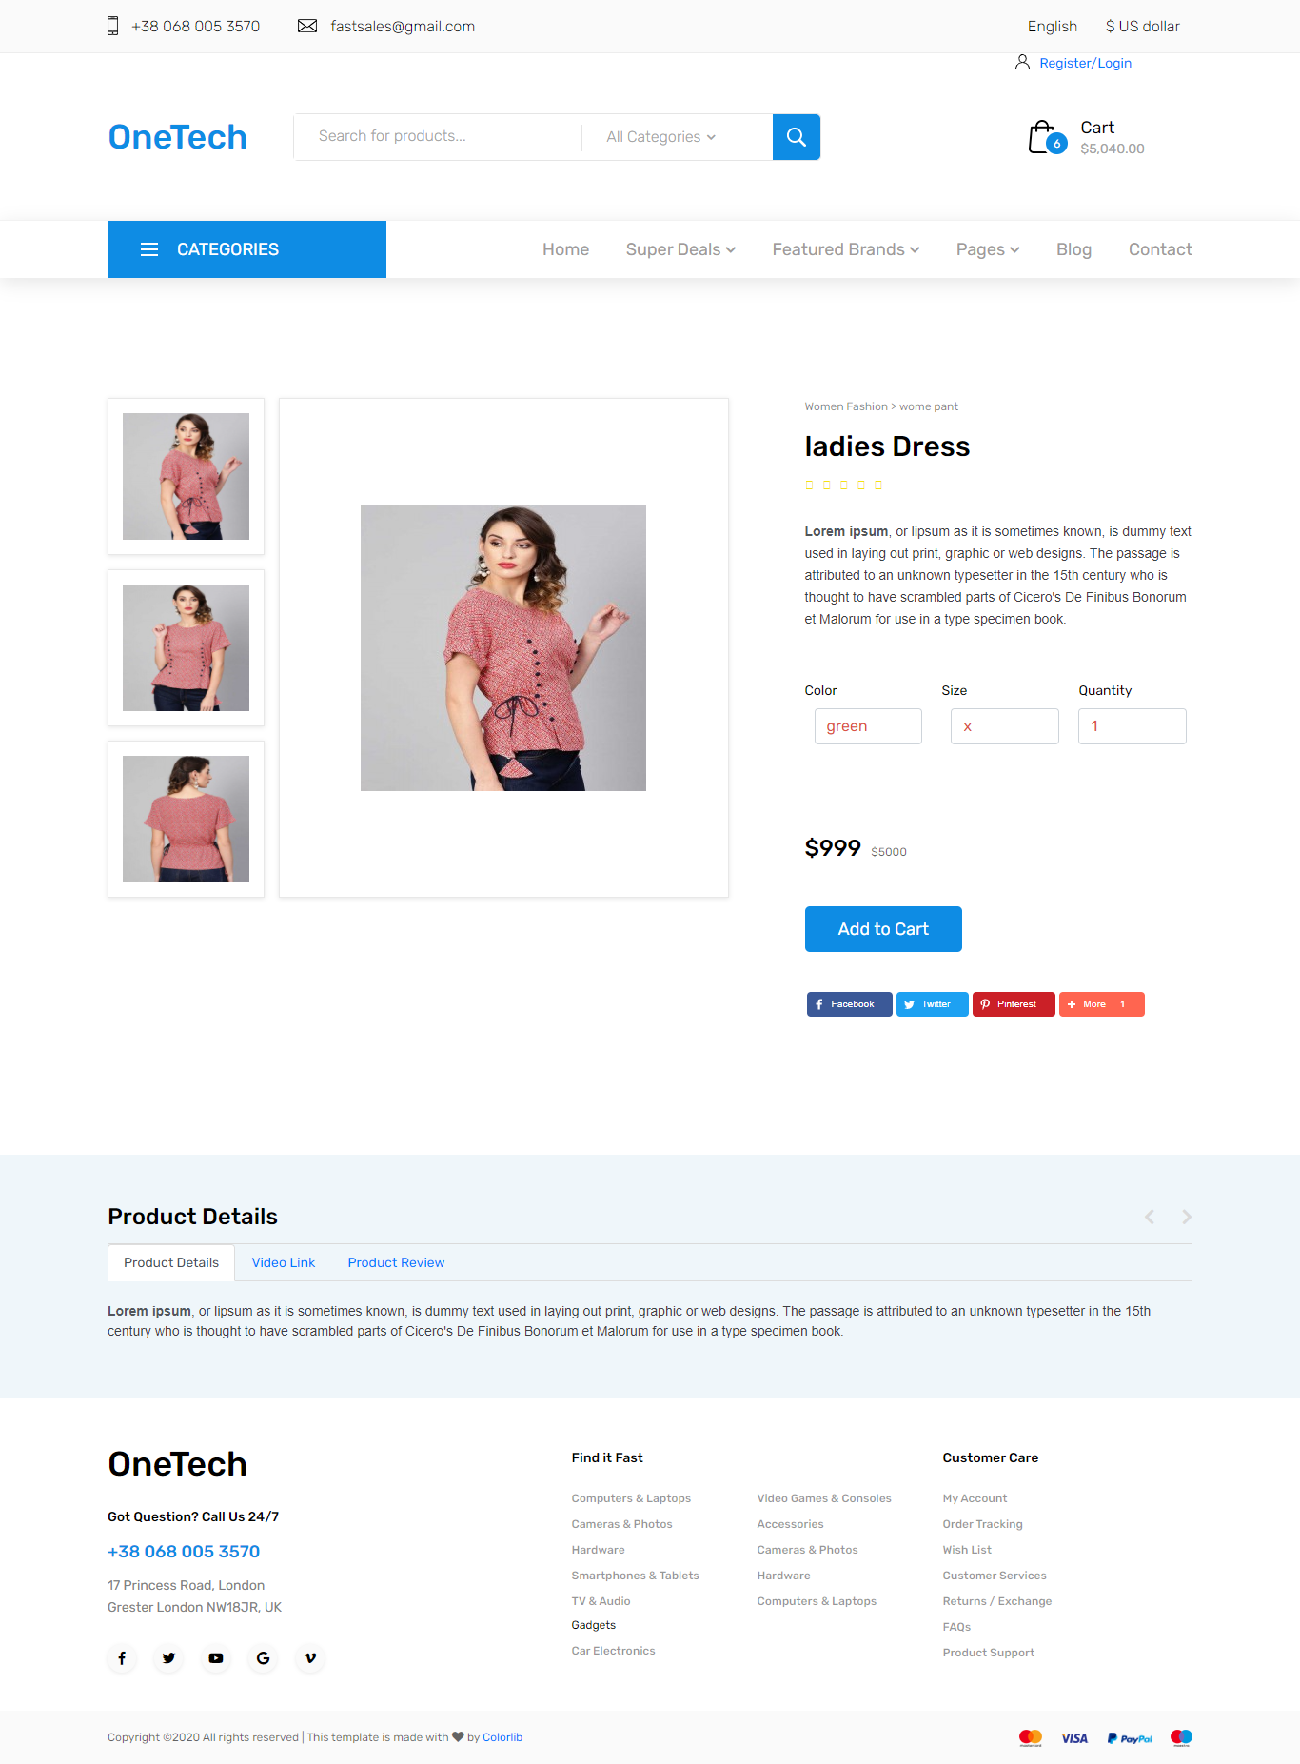

<div class="product_name"><div><a href="{{ url('product/details/'.$row->id.'/'.$row->product_name) }}">{{ $row->product_name }}</a></div></div>

Product detail page link

**Pop up model and ajax with single product show and add to card**

**button**

<div class="product_extras">

                <button id="{{ $row->id }}" class="product_cart_button addcart" data-toggle="modal" data-target="#cartmodal" onclick="productview(this.id)">Add to Cart</button>

                           </div>

**Jquery link**

<script

  src="https://code.jquery.com/jquery-3.4.1.min.js"

  integrity="sha256-CSXorXvZcTkaix6Yvo6HppcZGetbYMGWSFlBw8HfCJo="

  crossorigin="anonymous"></script>

sweet alert2 link:

<script src="https://cdn.jsdelivr.net/npm/sweetalert2@10"></script>

<link rel="stylesheet" href="sweetalert2.min.css">

{{-- Jquery cdn minified: --}}

<script src="https://code.jquery.com/jquery-3.5.1.min.js" integrity="sha256-9/aliU8dGd2tb6OSsuzixeV4y/faTqgFtohetphbbj0=" crossorigin="anonymous"></script>

**Ajax script**

<script type="text/javascript">

    function productview(id){

        $.ajax({

         url: "{{ url('/cart/product/view/') }}/"+id,

         type: "GET",

         dataType:"json",

         success:function(data){

       $('#pcode').text(data.product.product_code);

       $('#pcat').text(data.product.category_name);

       $('#psub').text(data.product.subcategory_name);

       $('#pbrand').text(data.product.brand_name);

       $('#pname').text(data.product.product_name);

       $('#pimage').attr('src',data.product.image_one);

       $('#product_id').val(data.product.id);

       var d = $('select[name="color"]').empty();

       $.each(data.color,function(key,value){

       $('select[name="color"]').append('<option value="'+value+'">'+value+'</option>');

        });

          var d = $('select[name="size"]').empty();

       $.each(data.size,function(key,value){

       $('select[name="size"]').append('<option value="'+value+'">'+value+'</option>');

        });

         }

        })

    }

</script>

**Web.php**

//modal ajax route

Route::get('/cart/product/view/{id}', 'CartController@ViewProduct');

Route::post('insert/into/cart/', 'CartController@insertCart')->name('insert.into.cart');

**cartController**

 public function ViewProduct($id){

            $product = DB::table('products')

                    ->join('categories','products.category_id','categories.id')

                    ->join('subcategories','products.subcategory_id','subcategories.id')

                    ->join('brands','products.brand_id','brands.id')

                    ->select('products.*','categories.category_name','subcategories.subcategory_name','brands.brand_name')

                    ->where('products.id',$id)

                    ->first();

            $color = $product->product_color;

            $product_color = explode(',', $color);

            $size = $product->product_size;

            $product_size = explode(',', $size);

       return response::json(array(

        'product' => $product,

        'color' => $product_color,

        'size' => $product_size,

       ));

        }

       public function insertCart(Request $request){

           $id = $request->product_id;

        $product = DB::table('products')->where('id',$id)->first();

        $color = $request->color;

        $size = $request->size;

        $qty = $request->qty;

      $data = array();

     if ($product->discount_price == NULL) {

         $data['id'] = $product->id;

         $data['name'] = $product->product_name;

         $data['qty'] = $request->qty;

         $data['price'] = $product->selling_price;

         $data['weight'] = 1;

         $data['options']['image'] = $product->image_one;

         $data['options']['color'] = $request->color;

         $data['options']['size'] = $request->size;

          Cart::add($data);

          $notification=array(

                            'messege'=>'Product Added Successfully',

                            'alert-type'=>'success'

                             );

                           return Redirect()->back()->with($notification);

     }else{

         $data['id'] = $product->id;

         $data['name'] = $product->product_name;

         $data['qty'] = $request->qty;

         $data['price'] = $product->discount_price;

         $data['weight'] = 1;

         $data['options']['image'] = $product->image_one;

         $data['options']['color'] = $request->color;

         $data['options']['size'] = $request->size;

          Cart::add($data);

          $notification=array(

                            'messege'=>'Product Added Successfully',

                            'alert-type'=>'success'

                             );

                           return Redirect()->back()->with($notification);

     }

       }

**Pop up Model**

<!-- Modal -->

<div class="modal fade" id="cartmodal" tabindex="-1" role="dialog" aria-labelledby="exampleModalLavel" aria-hidden="true">

    <div class="modal-dialog modal-lg" role="document">

      <div class="modal-content">

        <div class="modal-header">

          <h5 class="modal-title" id="exampleModalLavel">Product Quick View</h5>

          <button type="button" class="close" data-dismiss="modal" aria-label="Close">

            <span aria-hidden="true">&times;</span>

          </button>

        </div>

        <div class="modal-body">

         <div class="row">

          <div class="col-md-4">

              <div class="card">

                  <img src="" id="pimage" style="height: 220px; width: 200px;">

                  <div class="card-body">

                      <h5 class="card-title text-center" id="pname">  </h5>

                  </div>

              </div>

          </div>

  <div class="col-md-4">

              <ul class="list-group">

    <li class="list-group-item">Product Code:<span id="pcode"></span> </li>

    <li class="list-group-item">Category: <span id="pcat"></span></li>

    <li class="list-group-item">Subcategory: <span id="psub"></span></li>

    <li class="list-group-item">Brand:<span id="pbrand"></span> </li>

    <li class="list-group-item">Stock: <span class="badge" style="background: green;color: white;" > Available</span> </li>

  </ul>

          </div>

          <div class="col-md-4">

          <form method="post" action="{{ route('insert.into.cart') }}">

          @csrf

      <input type="hidden" name="product_id" id="product_id">

           <div class="form-group">

              <label for="exampleInputcolor">Color</label>

              <select name="color" class="form-control" id="color">

               </select>

           </div>

   <div class="form-group">

              <label for="exampleInputcolor">Size</label>

              <select name="size" class="form-control" id="size">

               </select>

           </div>

           <div class="form-group">

       <label for="exampleInputcolor">Quantity</label>

       <input type="number" class="form-control" name="qty" value="1">

           </div>

  <button type="submit" class="btn btn-primary">Add to Cart </button>

  </form>

          </div>

         </div>

        </div>

        <div class="modal-footer">

        </div>

      </div>

    </div>

  </div>

**Product checkout**

Page link

                                                        <li><a href="{{ route('user.checkout') }}">Checkout</a></li>

Web.php

Route::get('user/checkout/', 'CartController@Checkout')->name('user.checkout');

**---------------------------------------------------------------------**

**Passport package install**

**What is passport?**

Ans: Passport is a laravel official package ,when we create any api development for application ,then for creating this development when we use login ,so for access this log in we generate a token and this generated token is created by this passport package .It is used for 2 step authentication.

It means it is used for api authentication

first of all: if you are using laravel 6

1. composer require laravel/passport:7.5.1
2. in config/app.php add this line:
3. Laravel\Passport\PassportServiceProvider::class,
4. php artisan migrate
5. php artisan passport:install

**go->App\User:**

use Laravel\Passport\HasApiTokens;

class User extends Authenticatable

{

use HasApiTokens, Notifiable;

}

**Go->provider->AuthServiceProvider :**

use Laravel\Passport\Passport;

protected $policies = [

'App\Model' => 'App\Policies\ModelPolicy',

];

public function boot()

{

$this->registerPolicies();

Passport::routes();

}

**Go->config/auth.php**

'api' => [

'driver' => 'passport',

'provider' => 'users',

],

-----------------------------------------------

**What is payment getway?**

**Ans:**

---------------------------------------------------------------------

**Online Payment process strip api**

**Go,Strip.com->developer->libraries and sdks->home->developer tools->set up and intregation->development quick start->building with stripes->strip’s UI libraries->**

**Copy html ,css and javascripts code and paste in strip.blade.php**

**Then go,dashboars->developers->Api key**

**Copy publicable key and past in javascript code**

**((**

 <script type="text/javascript">

// Create a Stripe client.

var stripe =

Stripe('pk_test_51HbrSfDYzwcDLWcjjfZloJnSVZ2SuvstzGPzXJKmiXHNiYghcduF7kKdmvHIxdndNZWalIYPn9QtsXfAt6GeKME300KhQt9uA8');

**))**

## For strip function go ,strip.com-> developers->libraries and sdks->payments->More guides->About api’s row last one ->older apis->Using the older APIs

**->charges->storing information meta data->php->copy code**

**and paste it in strip function in controller**

then go ,dashboard ->developers->API key->click secreat key->copy this key and past in strip function ‘s set api keys position

 // Set your secret key: remember to change this to your live secret key in production

           // See your keys here: https://dashboard.stripe.com/account/apikeys

           \Stripe\Stripe::setApiKey('sk_test_51HbrSfDYzwcDLWcjnUh4WUOsA1mM7LlHLZFpmogFWemAbkOVr1jAkSFBU6Pl7fBzx3itz0OrDTc9OjwcGdnwGBzf00oziiNXvS');

## Go,Strip.com->developer->libraries and sdks->home->developer tools->set up and intregation->development quick start-> Install a client library->

composer require stripe/stripe-php

**facebook comment:**

**site:**

[**https://developers.facebook.com/docs/plugins/comments**](https://developers.facebook.com/docs/plugins/comments)

**script code:**

<div id="fb-root"></div>

<script async defer crossorigin="anonymous" src="https://connect.facebook.net/en_US/sdk.js#xfbml=1&version=v6.0"></script>

**Where u place the field,there paste:**

  <div class="fb-comments" data-href="{{ Request::url() }}" data-width="" data-numposts="5"></div>

**Social media share code:**

**Script:**

<!-- Go to www.addthis.com/dashboard to customize your tools -->

<script type="text/javascript" src="//s7.addthis.com/js/300/addthis_widget.js#pubid=ra-5f971bd3f230e021"></script>

         <!-- Go to www.addthis.com/dashboard to customize your tools -->

                <div class="addthis_inline_share_toolbox"></div>